Phoenix Primary School
Geography Policy 2024/25

Introduction
Geography is a valued part of the curriculum, providing a purposeful means for exploring, appreciating and understanding the world in which we live and how it has evolved. Geography explores the relationship between the Earth and its people through the study of place, space and environment. Geography is concerned with pupils learning about their own locality, whilst becoming aware of and developing knowledge and understanding of the world beyond their own environment.
Geography encourages children to learn through experience, particularly through practical and fieldwork activities. At Phoenix Primary School, we believe it is important to build a geographical curriculum that endorses the importance for outdoor learning to build a curiosity for learning to help them to know more, remember more and understand more.

Aims

The national curriculum for geography aims to ensure that all pupils:

develop contextual knowledge of the location of globally significant places – both terrestrial and marine – including their defining physical and human characteristics and how these provide a geographical context for understanding the actions of processes

understand the processes that give rise to key physical and human geographical features of the world, how these are interdependent and how they bring about spatial variation and change over time

are competent in the geographical skills needed to:

collect, analyse and communicate with a range of data gathered through experiences of fieldwork that deepen their understanding of geographical processes

interpret a range of sources of geographical information, including maps, diagrams, globes, aerial photographs and Geographical Information Systems (GIS)

communicate geographical information in a variety of ways, including through maps, numerical and quantitative skills and writing at length

National Curriculum
Early Years
Within the Early Years Foundation Stage, geography is included as part of Understanding the World. The children learn to investigate similarities and differences, the local environment and cultures and beliefs, fostering the skills essential to developing historical understanding. This is set out in the early year’s curriculum as children needing to:
- Observe, find out about, and identify features in the place they live and the natural world;
- Begin to know about their own cultures and beliefs and those of other people;
- Find out about their environment, and talk about those features they like and dislike.

Key Stage 1
Pupils should develop knowledge about the world, the United Kingdom and their locality.
They should understand basic subject-specific vocabulary relating to human and physical
geography and begin to use geographical skills, including first-hand observation, to
enhance their locational awareness.

Pupils should be taught:

Locational knowledge
- name and locate the world’s seven continents and five oceans
- name, locate and identify characteristics of the four countries and capital cities of the United Kingdom and its surrounding seas

Place knowledge
- understand geographical similarities and differences through studying the human and
physical geography of a small area of the United Kingdom, and of a small area in a contrasting non-European country

Human and physical geography
- identify seasonal and daily weather patterns in the United Kingdom and the location of hot and cold areas of the world in relation to the Equator and the North and South Poles
- use basic geographical vocabulary to refer to:
  - key physical features, including: beach, cliff, coast, forest, hill, mountain, sea, ocean, river, soil, valley, vegetation, season and weather
  - key human features, including: city, town, village, factory, farm, house, office, port, harbour and shop

Geographical skills and fieldwork
- use world maps, atlases and globes to identify the United Kingdom and its countries, as well as the countries, continents and oceans studied at this key stage
- use simple compass directions (North, South, East and West) and locational and directional language [for example, near and far; left and right], to describe the location of features and routes on a map
- use aerial photographs and plan perspectives to recognise landmarks and basic human and physical features; devise a simple map; and use and construct basic symbols in a key
- use simple fieldwork and observational skills to study the geography of their school and its grounds and the key human and physical features of its surrounding environment.

Key Stage 2
Pupils should extend their knowledge and understanding beyond the local area to include
the United Kingdom and Europe, North and South America. This will include the location
and characteristics of a range of the world’s most significant human and physical features.
They should develop their use of geographical knowledge, understanding and skills to
enhance their locational and place knowledge.

Pupils should be taught to:

Locational knowledge
- locate the world’s countries, using maps to focus on Europe (including the location of Russia) and North and South America, concentrating on their environmental regions, key physical and human characteristics, countries, and major cities
- name and locate counties and cities of the United Kingdom, geographical regions and their identifying human and physical characteristics, key topographical features (including hills, mountains, coasts and rivers), and land-use patterns; and understand how some of these aspects have changed over time
- identify the position and significance of latitude, longitude, Equator, Northern Hemisphere, Southern Hemisphere, the Tropics of Cancer and Capricorn, Arctic and Antarctic Circle, the Prime/Greenwich Meridian and time zones (including day and night)

Place knowledge
- understand geographical similarities and differences through the study of human and physical geography of a region of the United Kingdom, a region in a European country, and a region within North or South America

Human and physical geography
- describe and understand key aspects of:
  - physical geography, including: climate zones, biomes and vegetation belts, rivers, mountains, volcanoes and earthquakes, and the water cycle
  - human geography, including: types of settlement and land use, economic activity including trade links, and the distribution of natural resources including energy, food, minerals and water

Geographical skills and fieldwork
- use maps, atlases, globes and digital/computer mapping to locate countries and describe features studied
- use the eight points of a compass, four and six-figure grid references, symbols and key (including the use of Ordnance Survey maps) to build their knowledge of the United Kingdom and the wider world
- use fieldwork to observe, measure, record and present the human and physical features in the local area using a range of methods, including sketch maps, plans and graphs, and digital technologies.

INTENT
At Phoenix Primary School, our geography curriculum intends to inspire curiosity about the world and its diverse environments, peoples, cultures, and landscapes. The geography curriculum aims to foster a deep understanding of the interconnected nature of physical and human geography. Our intent is to develop well-rounded individuals who appreciate the importance of sustainability, global citizenship, and environmental stewardship.

Our curriculum intent is underpinned by the National Curriculum requirements for Geography, with key focus areas including locational knowledge, place knowledge, human and physical geography, geographical skills, and fieldwork. We aim to ensure that our pupils develop a solid foundation in geographical knowledge, vocabulary, and skills that they can apply both within and beyond the classroom.

IMPLEMENTATION – CUSP
A guiding principle of CUSP Geography is that each study draws upon prior learning. For example, in the EYFS, pupils may learn about People, Culture and Communities or The Natural World through daily activities and exploring their locality and immediate environment. This is revisited and positioned so that new and potentially abstract content in Year 1 can be put into a known location and make it easier to cognitively process. Pupils in EYFS explore globes and world locations through their curiosity corners, making links to where animals live. This substantive knowledge is used to remember and position the locations of continents and oceans, with more sophisticated knowledge. High volume and deliberate practice are essential for pupils to remember and retrieve substantive knowledge and use their disciplinary knowledge to explain and articulate what they know. This means pupils make conscious connections and think hard, using what they know. CUSP Geography is built around the principles of cumulative knowledge focusing on spaces, places, scale, human and physical processes with an emphasis on how content is connected and relational knowledge acquired. An example of this is the identification of continents, such as Europe, and its relationship to the location of the UK.
CUSP Geography equips pupils to become ‘more expert’ with each study and grow an ever broadening and coherent mental model of the subject. This guards against superficial, disconnected and fragmented geographical knowledge. Specific and associated geographical vocabulary is planned sequentially and cumulatively from Year 1 to Year 6. High frequency, multiple meaning words (tier 2) are taught and help make sense of subject specific words (tier 3). Each learning module in geography has a vocabulary module with teacher guidance, tasks and resources.
CUSP Geography is planned so that the retention of knowledge is much more than just ‘in the moment knowledge’. The cumulative nature of the curriculum is made memorable by the implementation of Bjork’s desirable difficulties, including retrieval and spaced retrieval practice, word building and deliberate practice tasks. This powerful interrelationship between structure and research-led practice is designed to increase substantive knowledge and accelerate learning within and between study modules. That means the foundational knowledge of the curriculum is positioned to ease the load on the working memory: new content is connected to prior learning. The effect of this cumulative model supports opportunities for children to associate and connect with places, spaces, scale, people, culture and processes.
Please see Appendix One for the content overview for Geography according to CUSP.

Planning
There is a programme of study for geography in place from Year 1 to Year 6 that is taught through our thematic curriculum – other areas of our curriculum link so that knowledge and skills are revisited regularly to ensure retention and mastery of skills.
Skills in the Foundation Stage are planned through the objectives within the EYFS.
The CUSP Geography Curriculum package includes a sequence of lesson plans, contextual reference materials, vocabulary modules, explanatory videos and annotated exemplifications.
The CUSP planning template recommends 6 phases of each lesson which aims to eradicate lesson ‘fade’. It adopts a teach – task – teach – task model. The Teach-Task cumulative sequence that draws on the six phases of a lesson supports coherent and effective creation of long-term memory. See the headlines and detail below:
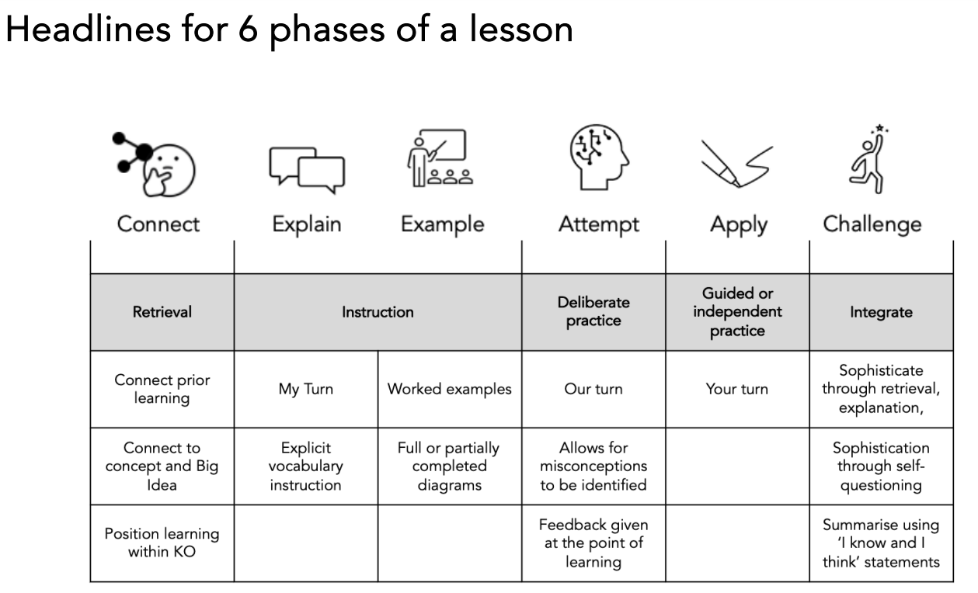
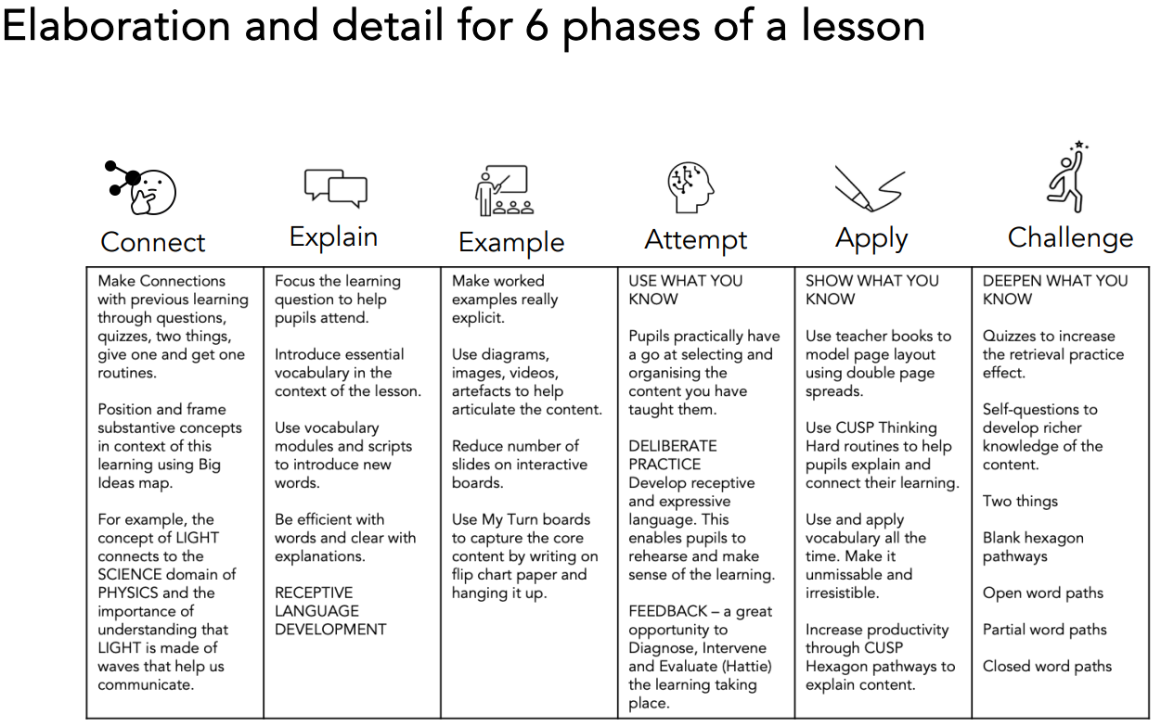

Record Keeping, Assessment and Reporting
Teachers will assess children’s Geography work in a variety of ways to ensure they gain a full understanding of what each child has learnt, and what is needed to progress their understanding. Teachers will observe, provide written and oral feedback. Teachers will use the statements on classroom monitor assessment system to support them to make an overall judgement of children’s geographic ability. Progression in geography is discussed in staff and moderation/standardisation meetings internally and externally. In addition, teacher assessments are recorded termly using the school’s assessment policy and reports to parents in an end of year written report.
Class teachers should keep records of work carried out, and levels of achievement of the work. Written work and photographs of practical lessons are useful, as a reminder of pupil’s achievement. Photographs are uploaded onto SeeSaw.
CUSP recommends that the assessment of pupils is formative based on pupil outcomes and questioning from each lesson. The following can be used to assess pupils’ knowledge and application of skills and their understanding and use of vocabulary.
The best form of assessment in Geography is in-action, while pupils are working. This helps us to understand pupils’ understanding and offers the teachers opportunity to support or challenge pupils. By encouraging pupils to articulate their thinking and application of skills, we can understand which aspects of geographical aspects they may require additional teaching in and reshape teaching to support this.
Children’s effort and progress in Geography is reported to parents through the pupil annual report and parents meetings throughout the year.

Reasonable adjustments for pupils with SEND:
As part of the planning and preparation for the delivery of each block from CUSP, teachers will need to consider how specific activities or the delivery may need to be adjusted to ensure that pupils with SEND are able to access the materials and participate fully in the lesson. Pupils with language and communication difficulties (including those with ASD) may need additional visual prompts to help them understand what is expected of them. Some pupils may require individual task boards to enable them to follow a series of steps where a task has been broken down into smaller, more manageable chunks. Some pupils may have sensory sensitivities. For those pupils, adjustments may need to be made in order for them to access materials. For example, pupils can be provided with crayons or pastels in paper sleeves. Pupils who have significant motor skill difficulties may require pencil grips or sloped surfaces to work on.

Speaking and Listening
Pupils are encouraged to provide specific evaluation of each other’s work through verbal peer-assessment strategies.

Monitoring
The monitoring of coverage and progress across the school will be done by the subject coordinator in consultation with teachers and the SLT.

Inclusion
At Phoenix Primary we plan to provide for all pupils to achieve, including boys and girls, higher achieving pupils, gifted and talented pupils, those with SEN, pupils with disabilities, pupils from all social and cultural backgrounds, children who are in care and those subject to safeguarding, pupils from different ethnic groups and those from diverse linguistic backgrounds.

Mission Statement
'Where We Rise To The Challenge'
Working together as a whole school community we aim for all pupils, parents and staff to increase their participation within our school. This is achieved through the development of inclusive cultures, policies and practices. We take account of disability, race and gender to create a secure and accepting community where everyone feels valued.
We strive towards an outstanding school that provides a creative and enriching learning experience for all pupils. We respond to the diversity of need through our commitment to equality; overcoming potential barriers to learning and setting suitable personalised targets.
We set high expectations and expect every child to thrive. They should reach their full potential, recognising personal strengths and celebrating personal achievements of themselves and others; both within the school and its wider community.

Equal Opportunity for specific groups including EAL children
Care should be taken to give each child the opportunity to learn about the global community, regardless of race, Religion, language or gender.

Health and Safety
Children should be working in a safe environment both in and outside of the classroom. The relevant risk assessments must be completed when using any potentially dangerous equipment, such as scissors or craft knifes. When conducting fieldwork, children should be properly supervised and should be made aware of any potential dangers, such as busy roads or water hazards.

Parental Involvement
As with all areas of children’s learning we need the support of parents and carers to help us to maximise the development of each child’s potential. This would include helping the child with any research or homework that may be set. Asking parents to come and share their skills and experiences. As well as joining in with the celebration of their children’s achievement and success.

Wellbeing
Mental health and wellbeing is at the forefront of everything we do, from children to all staff across the school. We have an open-door policy within our environment and we offer all the opportunity to express themselves appropriately and ensure that matters of concern are dealt with correctly and supportively.

Approved by Governors:
Name: ________________________ Signed: ______________________
Date: _____________________
To be reviewed: August 2025

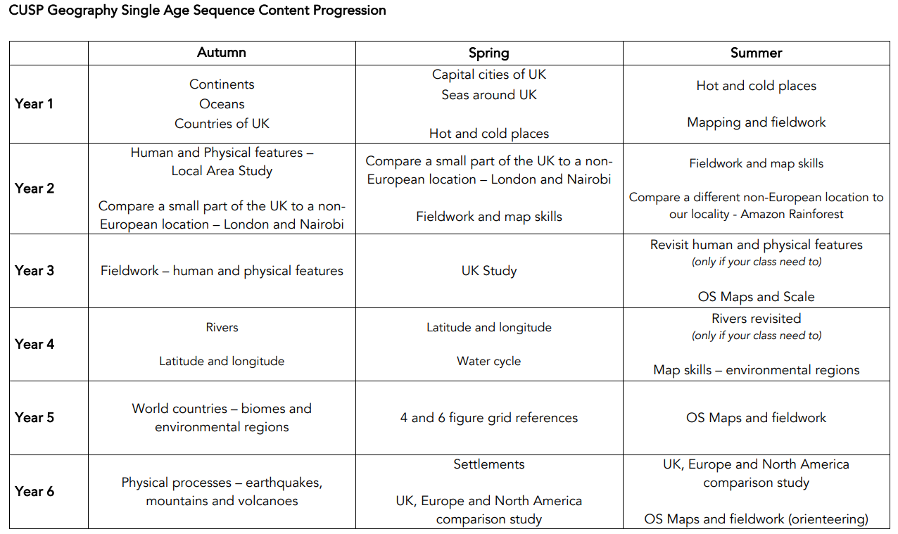
APPENDIX ONE – GEOGRAPHY SEQUENCE PROGRESSION & CUMULATIVE END GOALS (CUSP)



