Phoenix Primary School
History Policy 2024/25

Introduction
History is a valued part of the curriculum, offering a meaningful way to explore, appreciate, and understand the past and how it has shaped the world we live in today. Through the study of history, students examine the relationship between events, people, and societies over time, developing a deep understanding of how the present has been influenced by the past.
At Phoenix Primary School, history education begins with an exploration of pupils' own local community and heritage, gradually expanding to include broader national and global perspectives. We aim to cultivate a sense of identity and place in the world, while fostering an awareness of diverse cultures and histories beyond their immediate environment.
History encourages children to learn through inquiry and investigation, often utilizing hands-on experiences such as examining artefacts, re-enactments, and visits to historical sites. We believe in building a history curriculum that sparks curiosity and inspires students to know more, remember more, and understand more about the past, enabling them to make informed connections to the present and future.

Aims
The national curriculum for history aims to ensure that all pupils:
- know and understand the history of these islands as a coherent, chronological narrative, from the earliest times to the present day: how people’s lives have shaped this nation and how Britain has influenced and been influenced by the wider world
- know and understand significant aspects of the history of the wider world: the nature of ancient civilisations; the expansion and dissolution of empires; characteristic features of past non-European societies; achievements and follies of mankind
- gain and deploy a historically grounded understanding of abstract terms such as ‘empire’, ‘civilisation’, ‘parliament’ and ‘peasantry’
- understand historical concepts such as continuity and change, cause and consequence, similarity, difference and significance, and use them to make connections, draw contrasts, analyse trends, frame historically-valid questions and create their own structured accounts, including written narratives and analyses
- understand the methods of historical enquiry, including how evidence is used rigorously to make historical claims, and discern how and why contrasting arguments and interpretations of the past have been constructed
- gain historical perspective by placing their growing knowledge into different contexts, understanding the connections between local, regional, national and international history; between cultural, economic, military, political, religious and social history; and between short- and long-term timescales.

National Curriculum
Early Years
Within the Early Years Foundation Stage, history is integrated into the area of Understanding the World. Children are encouraged to explore similarities and differences, develop an awareness of their local environment, and begin to understand different cultures and beliefs.

These activities lay the foundation for historical understanding by helping children to:
- Observe, explore, and identify aspects of the past in their own surroundings and communities;
- Begin to learn about their own family history, cultural heritage, and the traditions of others;
- Discover and discuss historical features of their environment, expressing what they find interesting or important.

Key Stage 1
Pupils should develop an awareness of the past, using common words and phrases
relating to the passing of time. They should know where the people and events they study
fit within a chronological framework and identify similarities and differences between ways
of life in different periods. They should use a wide vocabulary of everyday historical terms.
They should ask and answer questions, choosing and using parts of stories and other
sources to show that they know and understand key features of events. They should
understand some of the ways in which we find out about the past and identify different
ways in which it is represented.

In planning to ensure the progression described above through teaching about the people,
events and changes outlined below, teachers are often introducing pupils to historical
periods that they will study more fully at key stages 2 and 3.

Pupils should be taught about:
- changes within living memory. Where appropriate, these should be used to reveal aspects of change in national life
- events beyond living memory that are significant nationally or globally [for example, the Great Fire of London, the first aeroplane flight or events commemorated through festivals or anniversaries]
- the lives of significant individuals in the past who have contributed to national and international achievements. Some should be used to compare aspects of life in different periods [for example, Elizabeth I and Queen Victoria, Christopher Columbus and Neil Armstrong, William Caxton and Tim Berners-Lee, Pieter Bruegel the Elder and LS Lowry, Rosa Parks and Emily Davison, Mary Seacole and/or Florence Nightingale and Edith Cavell]
- significant historical events, people and places in their own locality.

Key Stage 2
Pupils should continue to develop a chronologically secure knowledge and understanding
of British, local and world history, establishing clear narratives within and across the
periods they study. They should note connections, contrasts and trends over time and
develop the appropriate use of historical terms. They should regularly address and
sometimes devise historically valid questions about change, cause, similarity and
difference, and significance. They should construct informed responses that involve
thoughtful selection and organisation of relevant historical information. They should
understand how our knowledge of the past is constructed from a range of sources.

In planning to ensure the progression described above through teaching the British, local
and world history outlined below, teachers should combine overview and depth studies to
help pupils understand both the long arc of development and the complexity of specific
aspects of the content.

Pupils should be taught about:
- changes in Britain from the Stone Age to the Iron Age
- the Roman Empire and its impact on Britain
- Britain’s settlement by Anglo-Saxons and Scots
- the Viking and Anglo-Saxon struggle for the Kingdom of England to the time of Edward the Confessor
- a local history study
- a study of an aspect or theme in British history that extends pupils’ chronological knowledge beyond 1066
- the achievements of the earliest civilizations – an overview of where and when the first civilizations appeared and a depth study of one of the following: Ancient Sumer; The Indus Valley; Ancient Egypt; The Shang Dynasty of Ancient China
- Ancient Greece – a study of Greek life and achievements and their influence on the western world
- a non-European society that provides contrasts with British history – one study chosen from: early Islamic civilization, including a study of Baghdad c. AD 900; Mayan civilization c. AD 900; Benin (West Africa) c. AD 900-1300.

INTENT
At Phoenix Primary School, our history curriculum is designed to spark curiosity about the past and its impact on the present. We aim to instill a deep understanding of the events, people, and societies that have shaped our world. Our intent is to develop well-rounded individuals who appreciate the significance of history in understanding identity, culture, and the values of citizenship.

Our curriculum intent is guided by the National Curriculum requirements for History, with key focus areas including chronology, significant events and individuals, local and global history, and historical inquiry skills. We strive to ensure that our pupils build a strong foundation in historical knowledge, vocabulary, and critical thinking skills that they can apply both within and beyond the classroom.

IMPLEMENTATION – CUSP
A CUSP History draws upon prior learning, wherever the content is taught. For example, in the EYFS, pupils may learn about the past and present through daily activities, exploring through change, and understanding more about the lives of others through books and visitors as well as their own experiences. These experiences are drawn upon and used to position new learning in KS1.

The structure is built around the principles of advancing cumulative knowledge, chronology, change through cause and consequence, as well as making connections within and throughout periods of time studied.

CUSP History is planned so that the retention of knowledge is much more than just ‘in the moment knowledge’. The cumulative nature of the curriculum is made memorable by the implementation of Bjork’s desirable difficulties, including retrieval and spaced retrieval practice, word building and deliberate practice tasks. This powerful interrelationship between structure and research-led practice is designed to increase substantive knowledge and accelerate learning within and between study modules. That means the foundational knowledge of the curriculum is positioned to ease the load on the working memory: new content is connected to prior learning. The effect of this cumulative model supports opportunities for children to associate and connect with significant periods of time, people, places and events.

CUSP History strategically incorporates a range of modules that revisit, elaborate and sophisticate key concepts, events, people and places.

A guiding principle of CUSP History is that pupils become ‘more expert’ with each study and grow an ever broadening and coherent mental timeline. This guards against superficial, disconnected and fragmented understanding of the past. Specific and associated historical vocabulary is planned sequentially and cumulatively from Year 1 to Year 6. High frequency, multiple meaning words (Tier 2) are taught alongside and help make sense of subject specific words (Tier 3). Each learning module in history has a vocabulary module with teacher guidance, tasks and resources.

CUSP fulfils and goes well beyond the expectations of the National Curriculum as we believe there is no ceiling to what pupils can learn if the architecture and
practice is founded in evidence-led principles.

Please see Appendix One for the content overview for History according to CUSP.

Planning
There is a programme of study for geography in place from Year 1 to Year 6 that is taught through our thematic curriculum – other areas of our curriculum link so that knowledge and skills are revisited regularly to ensure retention and mastery of skills.
Skills in the Foundation Stage are planned through the objectives within the EYFS.
The CUSP History Curriculum package includes a sequence of lesson plans, contextual reference materials, vocabulary modules, explanatory videos and annotated exemplifications.
The CUSP planning template recommends 6 phases of each lesson which aims to eradicate lesson ‘fade’. It adopts a teach – task – teach – task model. The Teach-Task cumulative sequence that draws on the six phases of a lesson supports coherent and effective creation of long-term memory. See the headlines and detail below:
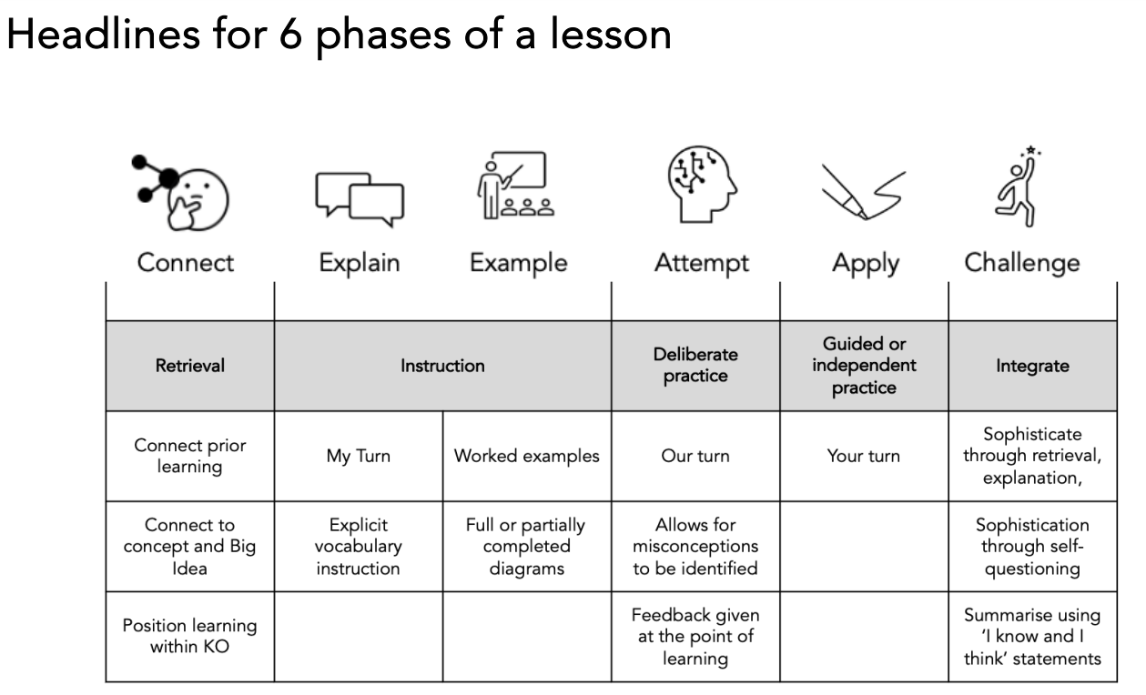
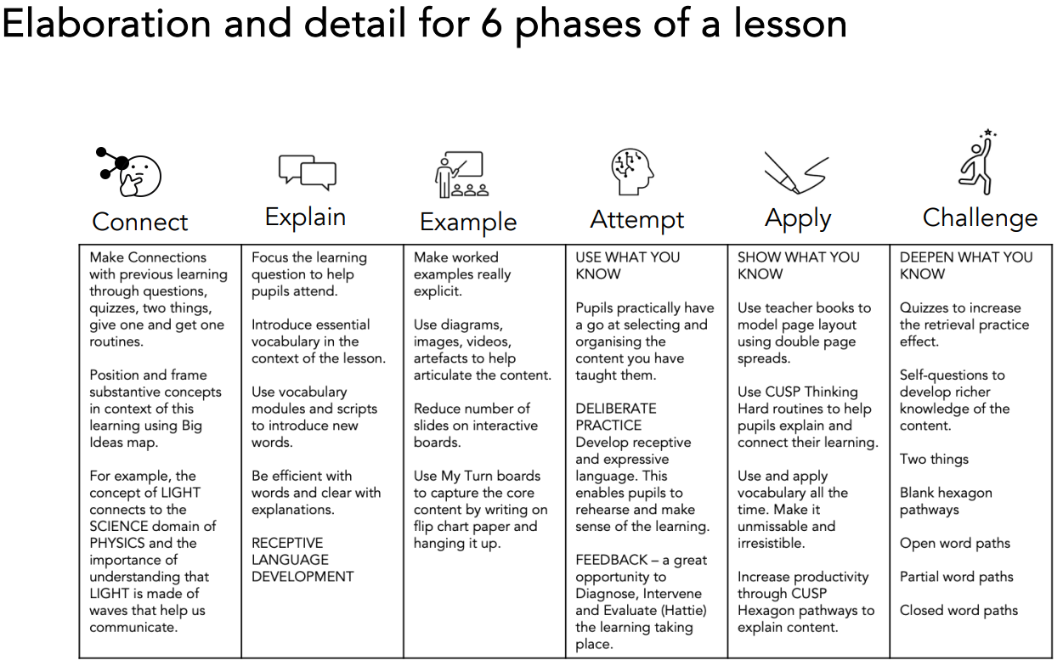

Record Keeping, Assessment and Reporting
Teachers will assess children’s history work in a variety of ways to ensure they gain a comprehensive understanding of each child’s learning and to identify what is needed to advance their historical knowledge. Teachers will observe students, provide written and oral feedback, and use the statements on the classroom monitor assessment system to make an overall judgment of each child's historical ability. Progression in history is discussed during staff meetings and moderation/standardisation sessions, both internally and externally. Teacher assessments are recorded termly in accordance with the school’s assessment policy and are communicated to parents in an end-of-year written report.
Class teachers should maintain records of the work completed and the levels of achievement reached by each student. Written work, along with photographs of practical activities, serve as valuable reminders of pupils’ accomplishments. These photographs are uploaded onto SeeSaw.
CUSP recommends that the assessment of pupils be formative, based on outcomes and questioning from each lesson. The following can be used to evaluate pupils’ knowledge, application of skills, and understanding and use of historical vocabulary.
The most effective form of assessment in history occurs in-action, while pupils are actively engaged in learning. This approach allows us to gauge pupils’ understanding in real time and provides teachers with opportunities to support or challenge them as needed. By encouraging pupils to articulate their thinking and demonstrate their skills, teachers can identify areas where additional instruction may be necessary and adjust their teaching strategies accordingly.
Children’s effort and progress in history are reported to parents through the annual pupil report and during parent meetings throughout the year.

Reasonable adjustments for pupils with SEND:
As part of the planning and preparation for the delivery of each block from CUSP, teachers will need to consider how specific activities or the delivery may need to be adjusted to ensure that pupils with SEND are able to access the materials and participate fully in the lesson. Pupils with language and communication difficulties (including those with ASD) may need additional visual prompts to help them understand what is expected of them. Some pupils may require individual task boards to enable them to follow a series of steps where a task has been broken down into smaller, more manageable chunks. Some pupils may have sensory sensitivities. For those pupils, adjustments may need to be made in order for them to access materials. For example, pupils can be provided with crayons or pastels in paper sleeves. Pupils who have significant motor skill difficulties may require pencil grips or sloped surfaces to work on.

Speaking and Listening
Pupils are encouraged to provide specific evaluation of each other’s work through verbal peer-assessment strategies.

Monitoring
The monitoring of coverage and progress across the school will be done by the subject coordinator in consultation with teachers and the SLT.

Inclusion
At Phoenix Primary we plan to provide for all pupils to achieve, including boys and girls, higher achieving pupils, gifted and talented pupils, those with SEN, pupils with disabilities, pupils from all social and cultural backgrounds, children who are in care and those subject to safeguarding, pupils from different ethnic groups and those from diverse linguistic backgrounds.

Mission Statement
'Where We Rise To The Challenge'
Working together as a whole school community we aim for all pupils, parents and staff to increase their participation within our school. This is achieved through the development of inclusive cultures, policies and practices. We take account of disability, race and gender to create a secure and accepting community where everyone feels valued.
We strive towards an outstanding school that provides a creative and enriching learning experience for all pupils. We respond to the diversity of need through our commitment to equality; overcoming potential barriers to learning and setting suitable personalised targets.
We set high expectations and expect every child to thrive. They should reach their full potential, recognising personal strengths and celebrating personal achievements of themselves and others; both within the school and its wider community.

Equal Opportunity for specific groups including EAL children
Care should be taken to give each child the opportunity to learn about the global community, regardless of race, Religion, language or gender.

Health and Safety
Children should be working in a safe environment both in and outside of the classroom. The relevant risk assessments must be completed when using any potentially dangerous equipment, such as scissors or craft knifes. When conducting fieldwork, children should be properly supervised and should be made aware of any potential dangers, such as busy roads or water hazards.

Parental Involvement
As with all areas of children’s learning we need the support of parents and carers to help us to maximise the development of each child’s potential. This would include helping the child with any research or homework that may be set. Asking parents to come and share their skills and experiences. As well as joining in with the celebration of their children’s achievement and success.

Wellbeing
Mental health and wellbeing is at the forefront of everything we do, from children to all staff across the school. We have an open-door policy within our environment and we offer all the opportunity to express themselves appropriately and ensure that matters of concern are dealt with correctly and supportively.

Approved by Governors:
Name: ________________________ Signed: ______________________
Date: _____________________
To be reviewed: August 2025

APPENDIX ONE – HISTORY SEQUENCE PROGRESSION & CUMULATIVE END GOALS (CUSP)


