Phoenix Primary School
Music 2024/25

Overview
The true beauty of music is that it connects people.
(Roy Ayres – American jazz, Soul and Funk composer)
Music is all around us. It is the soundtrack to our lives. Music connects us through people and places in our ever-changing world. It is creative, collaborative, celebratory and challenging. In our schools, music can bring communities together through the shared endeavour of whole- school singing, ensemble playing, experimenting with the creative process and, through the love of listening to friends and fellow pupils performing. The sheer joy of music making can feed the soul of a school community, enriching each student while strengthening the shared bonds of support and trust which make a great school. Music is universal language that embodies one of the highest forms of creativity. It is a universal language that can be accessed and enjoyed by all. It is vital in our children's education and at Scott Primary School we believe that music enriches, unites and liberates.

Aims/Objectives
- Know and understand how sounds are made and then organised into musical structures;
- Know how music is made through a variety of instruments;
- Know how music is composed and written down;
- Know how music is influenced by the time, place and purpose for which it was written;
- Develop the interrelated skills of performing, composing and appreciating music.

At Phoenix Primary School we also aim to:
- Develop the understanding that music can be a social or personal activity.
- Provide experiences and resources which promote knowledge, skills and understanding in music in relation to both their own and the musical traditions of others and of different ages.
- Promote an enjoyable musical curriculum for all children in the school with relevant differentiated experiences.
- Develop children’s ability to observe and respond to the world around them through the use of a wide variety of instruments and musical recordings.
- Through the encouragement of listening to instruments or music for a variety of different reasons, develop children’s listening skills.
- Develop children’s discussion and negotiating skills through working with other children on a given task.
- Celebrate the value of children’s work through recording and performance of their work.
- Recognise ways in which ICT skills may be incorporated into and developed by the Music Curriculum and used to enhance the children’s musical experiences.

1.3 National Curriculum

Foundation Stage
Pupils should be taught using ‘Musical Development Matters in the Early Years’ document alongside the Kapow scheme of work using the aspects of musical learning and development:
- Hearing and Listening
- Vocalising and Singing
- Moving and Dancing
- Exploring and Playing
Music is intertwined into all aspects of the EYFS curriculum and is taught both indoors and outdoors.

The National Curriculum for Music aims to ensure that all pupils:
By the end of Key Stage 1
  - To use voices expressively and creatively by singing songs and speaking chants and rhymes
  - To play tuned and un-tuned instruments musically
  - To listen with concentration and understanding to a range of high-quality live and recorded
music.
  - Experiment with, create, select and combine sounds using the interrelated dimensions of music.
By the end of Key Stage 2
Pupils should be taught to sing and play musically with increasing confidence and control. They should develop an understanding of musical composition, organising and manipulating ideas within musical structures and reproducing sounds from aural memory. Pupils should be taught to:
  - Play and perform in solo and ensemble contexts, using their voices and playing musical instruments with increasing accuracy, fluency, control and expression.
  - Improvise and compose music for a range of purposes using the interrelated dimensions of music.
  - Listen with attention to detail and recall sounds with increasing aural memory.
  - Use an understand staff and other musical notations.
  - Appreciate and understand a wide range of high-quality live and recorded music drawn from different traditions and from great composers and musicians
  - Develop an understanding of the history of music.

The Model Music Curriculum 2021 (MMC)
A new Model Music Curriculum was introduced in March 2021 and will be implemented into our school curriculum from September 2021. The aim of the MMC is to ensure a universal provision of music education, for all pupils in all schools. In time and resources, this provision is as follows:
- At Key Stages 1 and 2, pupils should receive a minimum of 45 minutes of teaching a week; this may take the form of short sessions spread across the week.
- In Years 3 or 4, it is recommended that each class should start a whole-class instrumental programme lasting a minimum of one term. The mandatory term will be supported by teachers from the local Music Education Hub. Opportunities for development should continue beyond the mandatory term.
- There should be access to both rhythmic and melodic instruments in Key Stages 1 and 2; this may be as part of the whole-class instrumental programme and/or in other classroom teaching.

The National Plan for Music Education 2023 (NPME)
The National Plan for Music outlines the Government’s vision for music education and how this can be achieved through partnerships with schools, music hubs, the music and creative sector, and others. The Key Features of High-Quality Provision (as outlined in the National Plan for Music Education 2022) are as follows:
1. Curriculum music is timetabled for at least one hour each week of the school year.
2. Access to lessons across a range of instruments and voice is provided.
3. A school choir and/or vocal ensemble is developed.
4. A school ensemble/band/group is developed.
5. A space for rehearsals and individual practice is provided.
6. Pupils have opportunities to perform at school termly.
7. Pupils are given the opportunity to enjoy live performance at least once a year.

1.4 Strategies
- Pupils will be taught to use a range of materials creatively to design and make products.
- Pupils will be taught how to develop a wide range of design techniques in using colour, pattern, texture, line, shape, form and space.
- Pupils will be taught to develop their techniques, including their control and their use of materials, with creativity, experimentation and an increasing awareness of different kinds o f design.
- All children will be encouraged and shown how to improve their mastery of design techniques, including drawing.
- All will learn about the work of a range of designers, evaluating their designs and comparing their work.

Roles
The Subject Leader’s role is:
- Prepare policy and develop policy
- Provide consultancy, advice, skills
- Specifying and ordering resources in Music.
The teacher’s role is:
- Plan for and teach exciting and stimulating music lesson.
- Use assessment to influence future planning.

Outcomes
At Phoenix Primary School, the intention is first, and foremost, to help children to feel that they are musical, and to develop a life-long love of music. We focus on developing the skills, knowledge and understanding that children need in order to become confident composers, performers, and listeners. Our curriculum introduces children to music from all around the world, and across generations, teaching children to respect and appreciate music of all traditions and communities.
Children will develop the musical skills of singing, playing tuned and untuned instruments, improvising and composing music, and listening and responding to music. They will develop an understanding of the history and cultural context of music that the listen to, and learn how music can be written down. Through music, our curriculum helps children develop transferable skills such as team-working, leadership, creative-thinking, problem-solving, decision-making, and presentation and performance skills. These skills are vital to children’s development as leaners and have a wider application in their general lives outside and beyond school.

INTENT & IMPLEMENTATION - KAPOW
At Phoenix Primary School, we follow the Kapow Music scheme of work, which enables pupils to meet the end of key-stage attainment targets outlined in the national curriculum.
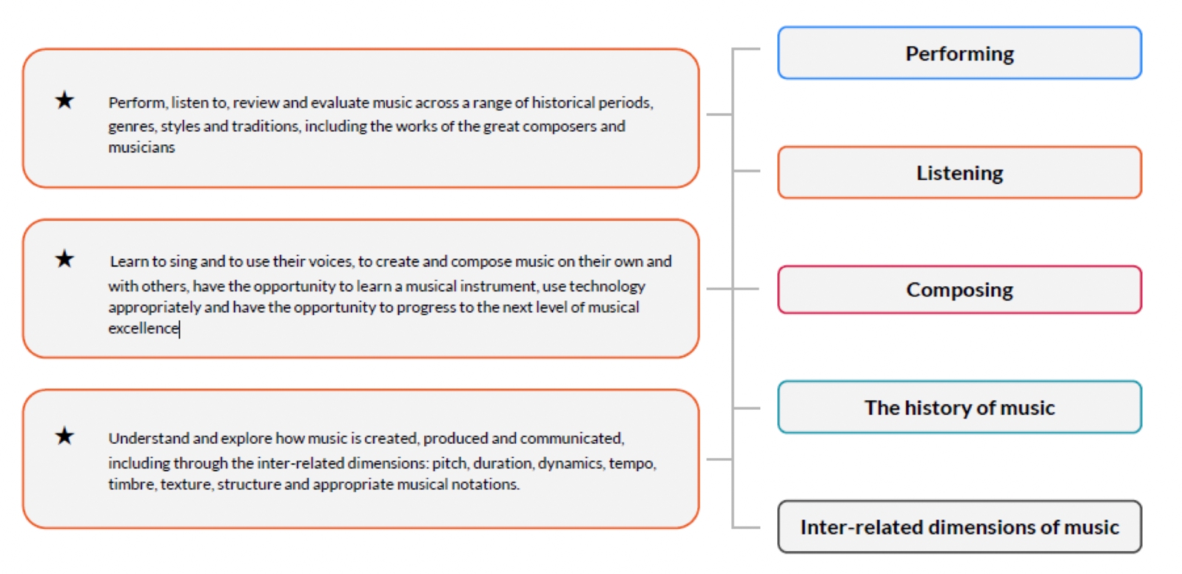
The Kapow scheme takes a holistic approach to music, in which the individual strands below are woven together to create engaging and enriching learning experiences:
- Performing
- Listening
- Composing
- The history of music
- The inter-related dimensions of music.

Each five-lesson unit combines these strands within a cross-curricular topic designed to capture pupils’ imagination and encourage them to explore music enthusiastically. Over the course of the scheme, children will be taught how to sing fluently and expressively, and play tuned and untuned instruments accurately and with control. They will learn to recognise and name the interrelated dimensions of music – pitch, duration, tempo, timbre, structure, texture ad dynamics – and use these expressively in their own improvisations and compositions.
The instrumental scheme lessons complement the Kapow Music scheme of work and allow for lower Key Stage 2 pupils to develop their expertise in using a tuned instrument for a minimum of one term as recommended in the DfE’s Model Music Curriculum 2021.
The Kapow Primary scheme follows the spiral curriculum model, where previous skills and knowledge are returned to and built upon. Progression in skills and knowledge is mapped across year groups, ensuring a clear trajectory of learning from Early Years to the end of Key Stage 2.
Children progress in terms of tackling more complex tasks and doing more simple tasks better, as well as developing understanding and knowledge of the history of music, staff, and other musical notations, as well as the interrelated dimensions of music and more.
Kapow Music scheme has been designed as a spiral curriculum with the following key principles in mind:
• Cyclical: Pupils return to the same skills and knowledge again and again during their time in primary school
• Increasing depth: Each time a skill or area of knowledge is revisited it, is covered with greater depth
• Prior knowledge: Upon returning to a skill, prior knowledge is utilised so pupils can build upon previous foundations, rather than starting again
In each lesson, pupils will actively participate in musical activities drawn from a range of styles and traditions, developing their musical skills and their understanding of how music works. Lessons incorporate a range of teaching strategies from independent tasks, paired and group work as well as improvisation and teacher-led performances. Lessons are ‘hands-on’ and incorporate movement and dance elements, as well as making cross-curricular links with other areas of learning.
Differentiated guidance is available for every lesson to ensure that lessons can be accessed by all pupils and opportunities to stretch pupils’ learning are available when required.

Planning
We provide opportunities for all children to create, play, perform and enjoy music, to develop the skills to appreciate a wide variety of musical genres and to begin to form opinions and critique the quality of music.

A progression of lessons will be planned over a five or six week blocked unit of work that is taught over a half term. The Music units of work will be taught during specific terms where strong and purposeful musical links can be made (see Kapow condensed Scheme of Work).

Music teaching and learning follows the scheme of work from ‘Kapow’, an online subscription service. This in-turn informs the medium-term planning as to what is taught within Music teaching units.

The short-term plan lists specific learning objectives that are to be covered and success criteria to support both children and adults in assessing their work and detailed plans are accessed through a log in portal on Kapow.

Teachers from the Foundation Stage to Year 6 will plan to ensure full coverage of the skills relating to the Music curriculum for that year group throughout the year. Teachers will plan before the start of each new theme, and at this point highlight the skills to be covered. Although the individual lessons might, by the very nature of creativity, be slightly different from class to class within a year group, the most important aspect to consider is the skills that need to be covered.

Record Keeping, Assessment and Reporting
As with all areas of the curriculum, assessment is an integral part of the teaching process. Class teachers should keep records of work carried out, and levels of achievement of the work. Photographs are a useful tool to keep, as a reminder of pupil’s achievement. These are uploaded onto SeeSaw.
Kapow recommends that assessment of pupils is formative and is based on pupil outcomes and questioning from each lesson. The following can be used to assess pupils’ knowledge and application of skills and techniques as well as their understanding and use of relevant vocabulary.
The impact of the music curriculum can be constantly monitored through both formative and summative assessment opportunities. Each lesson includes guidance to support teachers in assessing pupils against the learning objectives and the end of each unit, there is often a performance element where teachers can make a summative assessment of pupils’ learning.

Monitoring and Evaluation
The teaching and learning of Music will be monitored through the analysis of medium term planning, pupil interviews, analysis of assessment data and scrutiny of work samples.
The policy for Music will be reviewed. Evaluation will take into account:
• External inspection / advice
• Staff development
• Coverage of objectives

Hygiene and Safety
It is important that children are taught essential life skills to enable them to participate confidently in being part of a musical society. Teachers have a duty to introduce children to a wide variety of music making, whether that is with their bodies or instruments. Children must consider health and safety issues and consequences and operate in a safe and hygienic manner when using their insturments. The subject leader, if required, supports teachers to teach the skills necessary ensuring that children can do this safely.

Wellbeing
Mental health and wellbeing is at the forefront of everything we do, from children to all staff across the school. We have an open door policy within our environment and we offer all the opportunity to express themselves appropriately and ensure that matters of concern are dealt with correctly and supportively.

Inclusion
At Phoenix Primary we plan to provide for all pupils to achieve, including boys and girls, higher achieving pupils, gifted and talented pupils, those with SEN, pupils with disabilities, pupils from all social and cultural backgrounds, children who are in care and those subject to safeguarding, pupils from different ethnic groups and those from diverse linguistic backgrounds.

Reasonable adjustments for pupils with SEND:
As part of the planning and preparation for the delivery of each block, teachers will need to consider how specific activities, or the delivery, may need to be adjusted to ensure that pupils with SEND are able to access the materials and participate fully in the lesson.
Pupils with language and communication difficulties (including those with ASD) may need additional visual prompts to help them understand what is expected of them. The task could be broken down into smaller, more manageable chunks and individual task boards used to demonstrate these. Some pupils may have sensory sensitivities. For those pupils, adjustments may need to be made in order for them to access materials. Pupils who have difficulties with tasks requiring fine motor skills may need appropriate adjustments to be made to enable them to access the task and / or in order to keep them safe.

Mission Statement
'Where We Rise To The Challenge'
Working together as a whole school community we aim for all pupils, parents and staff to increase their participation within our school. This is achieved through the development of inclusive cultures, policies and practices. We take account of disability, race and gender to create a secure and accepting community where everyone feels valued.
We strive towards an outstanding school that provides a creative and enriching learning experience for all pupils. We respond to the diversity of need through our commitment to equality; overcoming potential barriers to learning and setting suitable personalised targets.
We set high expectations and expect every child to thrive. They should reach their full potential, recognising personal strengths and celebrating personal achievements of themselves and others; both within the school and its wider community.

Equal Opportunity for specific groups including EAL children
Care should be taken to give each child the opportunity to learn about the global community, regardless of race, Religion, language or gender.

Parental Involvement
As with all areas of children’s learning we need the support of parents and carers to help us to maximise the development of each child’s potential. This would include helping the child with any research or homework that may be set. Asking parents to come and share their skills and experiences. As well as joining in with the celebration of their children’s achievement and success

Approved by Governors:
Name: ________________________ Signed: ______________________
Date: _____________________

To be reviewed: September 2025

1 APPENDIX ONE – KAPOW LONG TERM PLAN



